AutoFix Desk: Automated L1 Support & Security Triage Toolkit

Comprehensive Project Documentation & Execution Guide

Executive Summary
AutoFix Desk is a Python and PowerShell-driven toolkit designed to replicate and automate Tier 1 (L1) Service Desk operations. It automatically diagnoses system health, applies remediation scripts, logs tickets into a database, escalates unresolved incidents to L2, routes security anomalies to a Security Operations Center (SOC) queue, and generates daily Management Information System (MIS) reports.

1. System Architecture & Component Breakdown
The toolkit consists of modular Python scripts and PowerShell execution hooks:

Component | Module Name | Primary Function
Control Center | main.py | Serves as the Command Line Interface (CLI) entry point (scan, fix, report, demo).
Health Diagnostic Engine | diagnostics.py | Checks endpoint metrics including connectivity, DNS resolution, C drive disk space, CPU/RAM utilization, Print Spooler service status, and Windows Security Event Logs (Event ID 4625 for failed logons).
Remediation Module | fixer.py | Executes automated fixes such as flushing DNS cache, renewing IP configuration, clearing temporary directories, and restarting stopped services.
Database & Ticketing Engine | ticket_logger.py | Manages SQLite/CSV ticket entries, assigning incident IDs (e.g., INC20261027-0001), severity levels (P1-P4), SLA timers, and audit trails.
Triage & Routing Engine | escalation.py | Handles workflow logic for unresolved incidents (escalating to L2 with logs) and routes security anomalies (repeated failed logins) directly to a SOC queue.
Reporting Engine | mis_report.py | Uses pandas and openpyxl to calculate KPIs (Total Tickets, Auto-resolution %, SLA Met %, Escalation Rate, Avg Resolution Time) and output Excel/HTML reports.

2. Execution Screenshots & Technical Descriptions

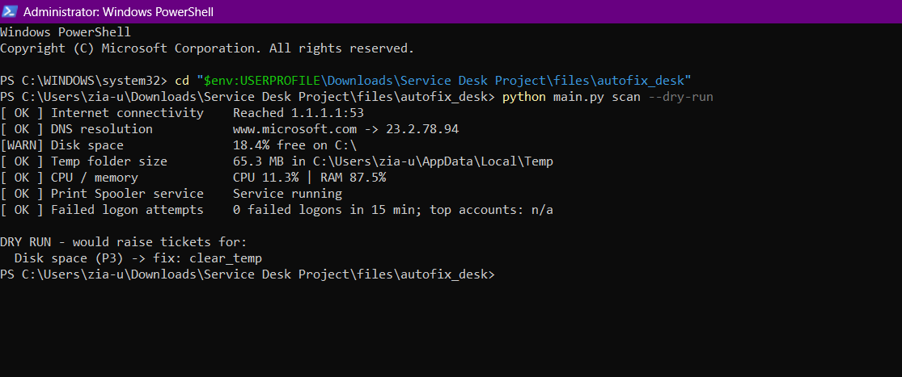

Figure 1: Health Diagnostic Dry Run Scan
Description: Demonstrates python main.py scan --dry-run executing in an Administrator PowerShell prompt. It checks network connectivity, DNS, disk space, temp folder size, CPU/RAM, Print Spooler, and Security Event Logs (0 failed logons in 15 mins). It flags low disk space (18.4% free on C:) and queues a dry-run fix recommendation (clear_temp).

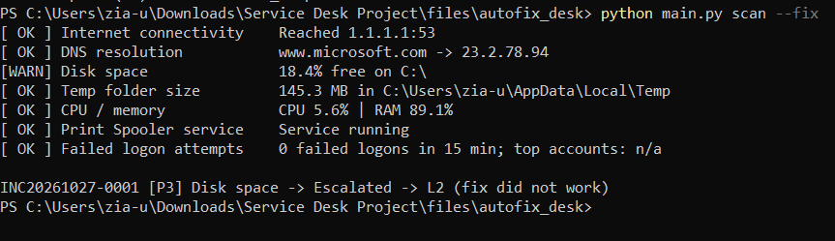

Figure 2: Live Auto-Fix Execution and L2 Escalation
Description: Shows python main.py scan --fix executing remediation. The toolkit cleared temporary files, but because disk space remained below the safe threshold, it automatically generated ticket INC20261027-0001 [P3] and escalated it to L2 Support (fix did not work) with system diagnostic logs attached.

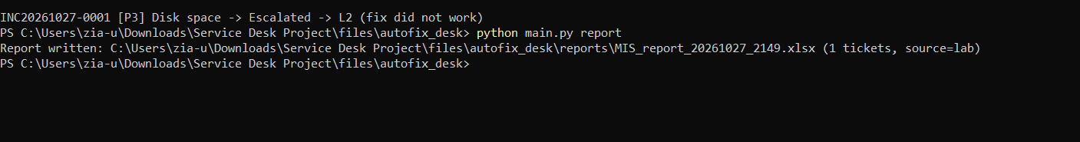

Figure 3: Automated MIS Excel Report Generation
Description: Highlights the reporting engine command python main.py report. The script queried the SQLite database, processed ticket metrics, and compiled a daily management report saved at C:\Users\zia-u\Downloads\Service Desk Project\files\autofix_desk\reports\MIS_report_20261027_2149.xlsx.

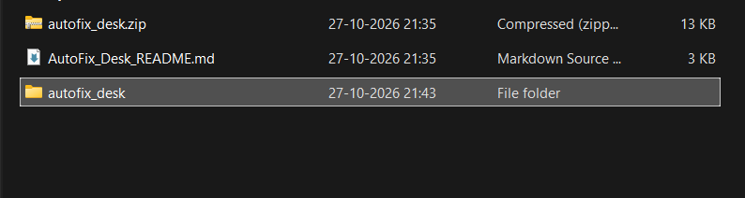

Figure 4: File Structure & Workspace Directory
Description: Illustrates the Windows File Explorer workspace structure. It displays autofix_desk.zip, AutoFix_Desk_README.md, and the extracted project directory autofix_desk containing source scripts, configuration files, and database schemas.

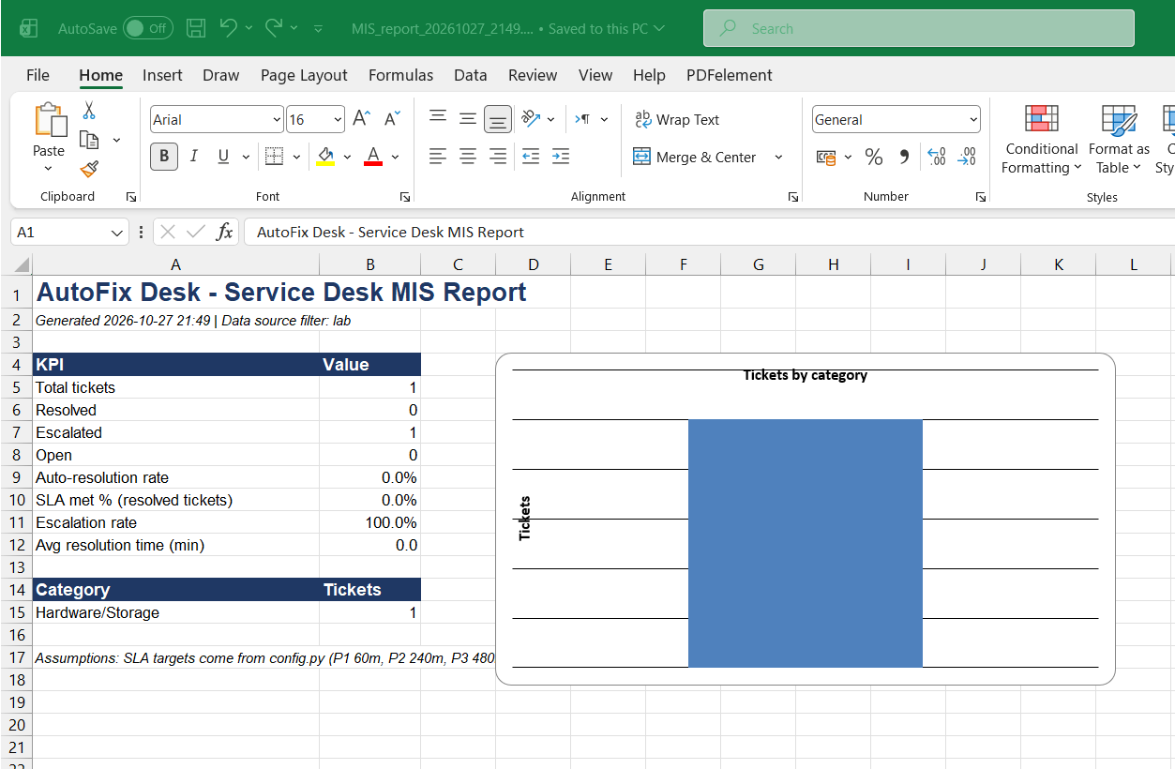

Figure 5: Excel MIS Management Dashboard
Description: Shows the generated Excel file opened in Microsoft Excel. It includes key operational metrics (Total Tickets: 1, Escalated: 1, Escalation Rate: 100%, Category: Hardware/Storage) alongside an automatically generated visual bar chart of ticket categories.

Conclusion
AutoFix Desk successfully demonstrates how Tier 1 (L1) IT Service Desk operations can be fully automated using lightweight, modular Python and PowerShell scripts.
By combining automated endpoint health diagnostics, instant remediation routines, structured SQLite ticket logging, and automated Excel MIS reporting, the project drastically reduces manual technician overhead, lowers mean time to resolution (MTTR), and eliminates human error in ticket logging and escalation.
Furthermore, the integration of security log analysis—specifically detecting repeated failed logon attempts and routing potential brute-force threat vectors to a dedicated Security Operations Center (SOC) queue—bridges the critical gap between traditional IT service desk support and modern cybersecurity incident response.
This end-to-end implementation serves as a practical, production-ready proof-of-concept for enterprise-grade endpoint triage, incident escalation, and security automation.

